**Exercise 03 - Gitlab and collaborative version control**

My project:

1. Created a repository and pushed a simple HTML document.

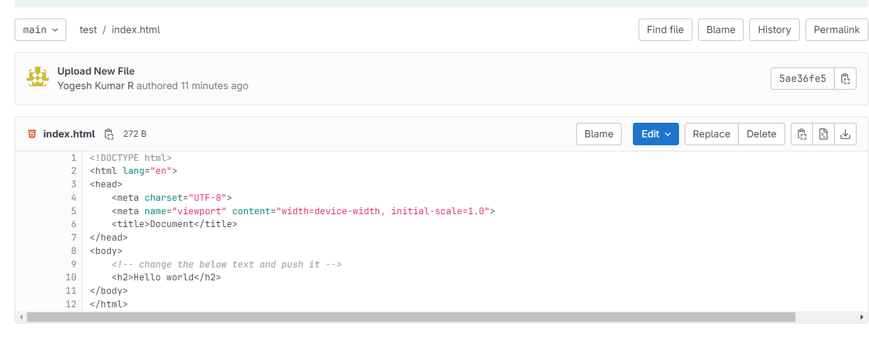

1. Created a new branch “Working branch” and made a small change

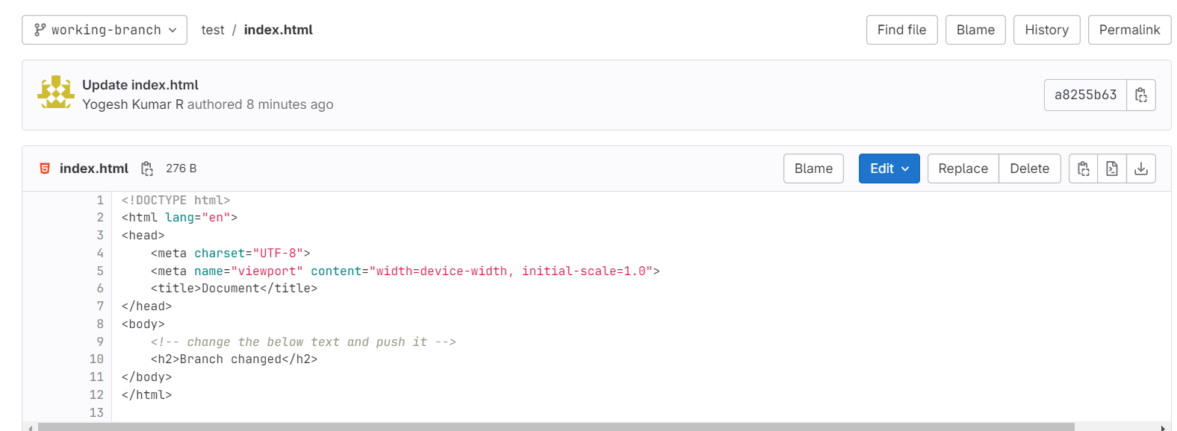

1. Shared the repository link to my batchmate and he made a small change and requested to merge the changes.

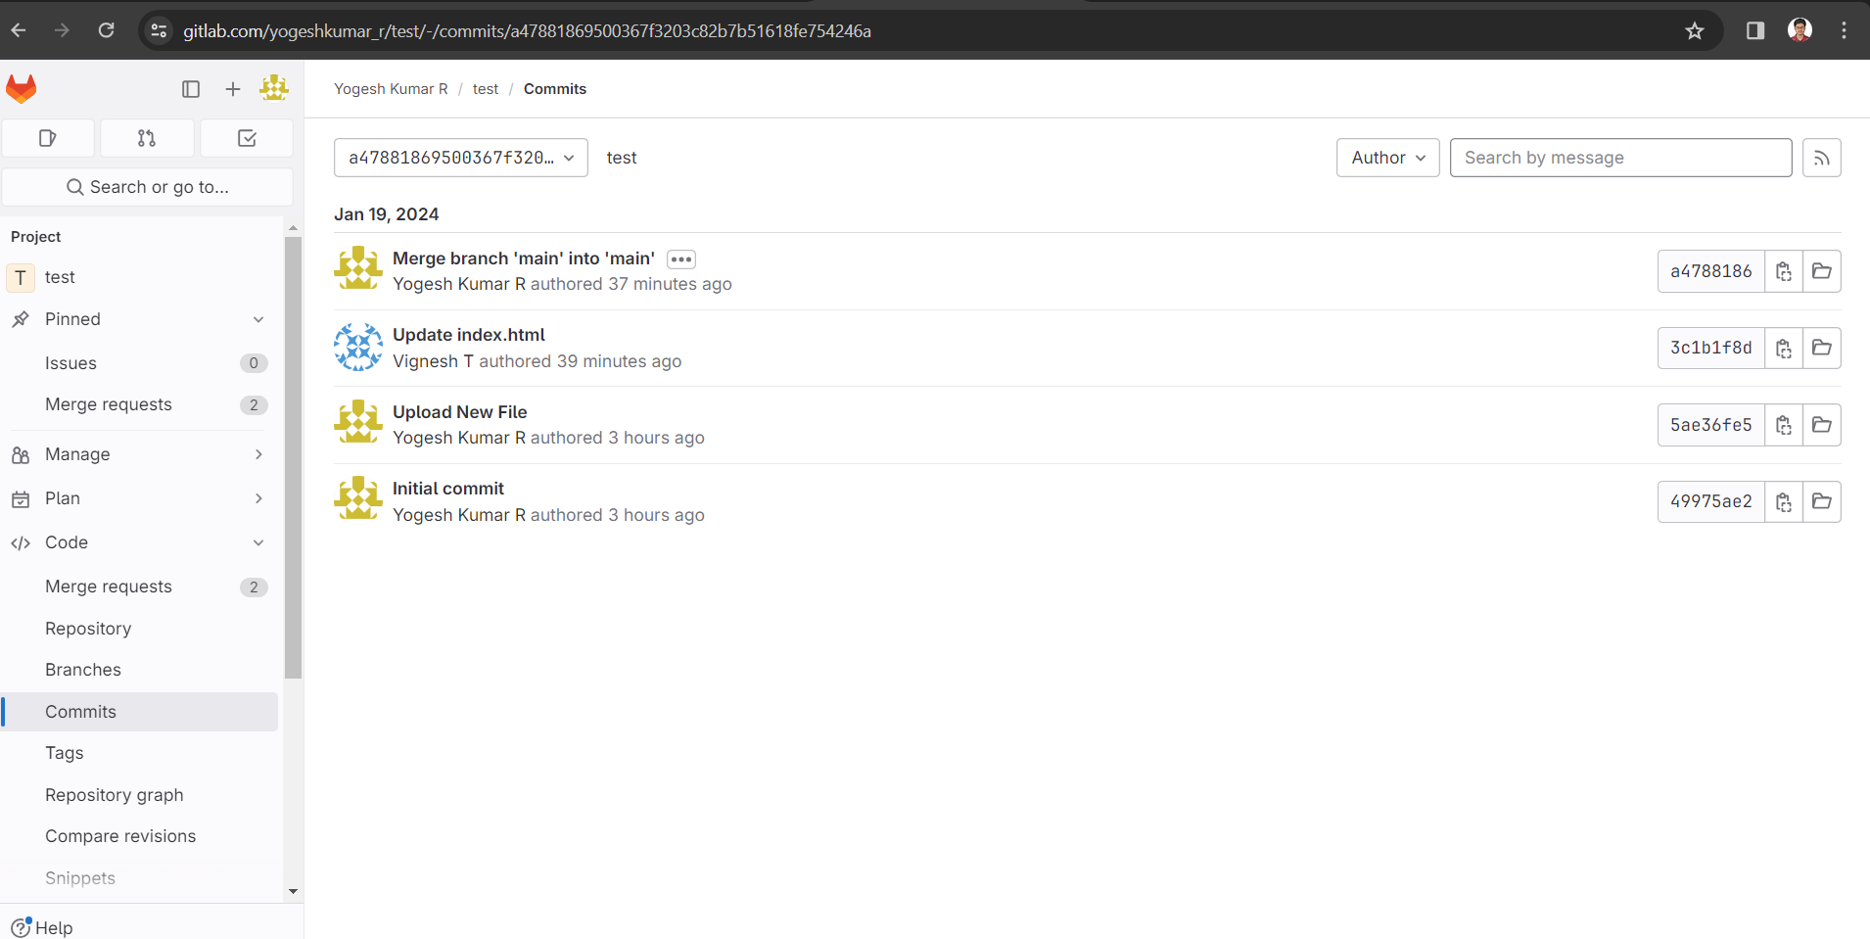

1. Approved the merge request

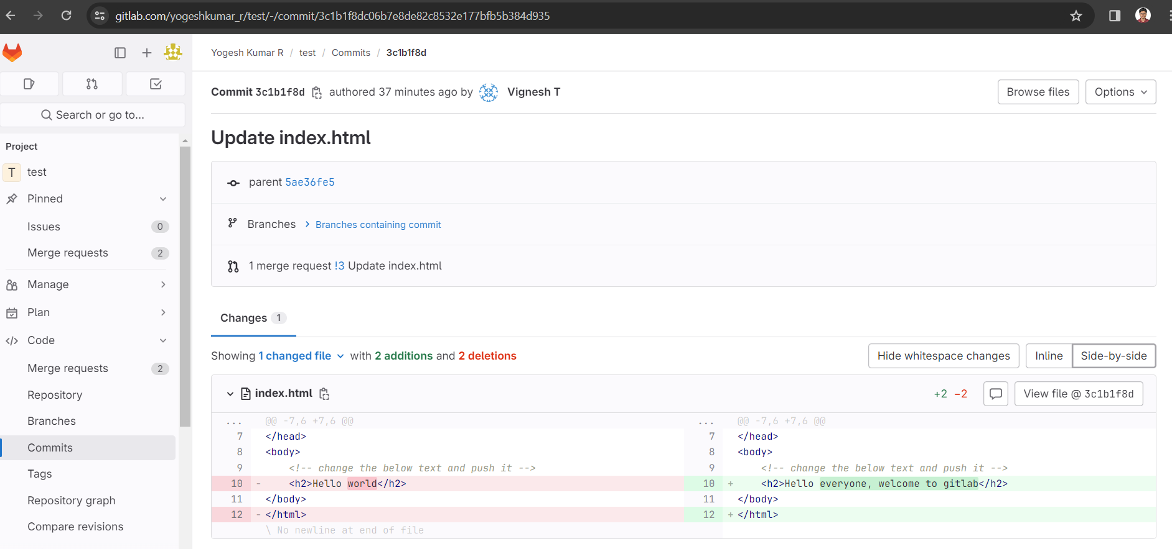

Reviewed Project:

1. Forked the project from my batchmate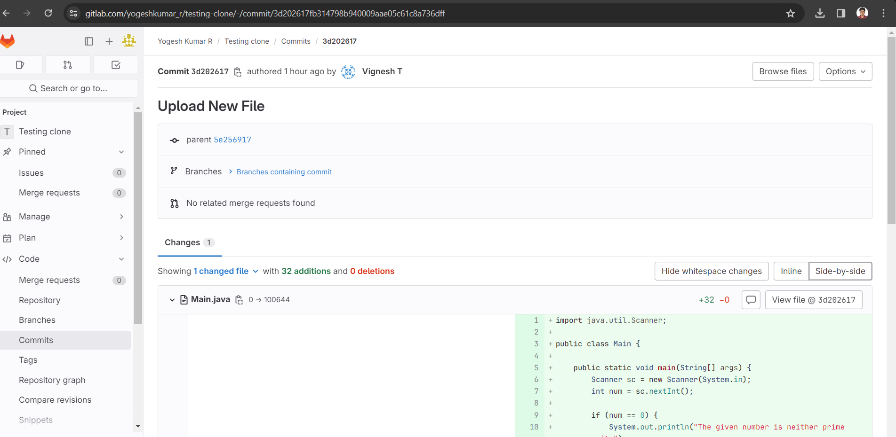
2. Reviewed and made changes to the file

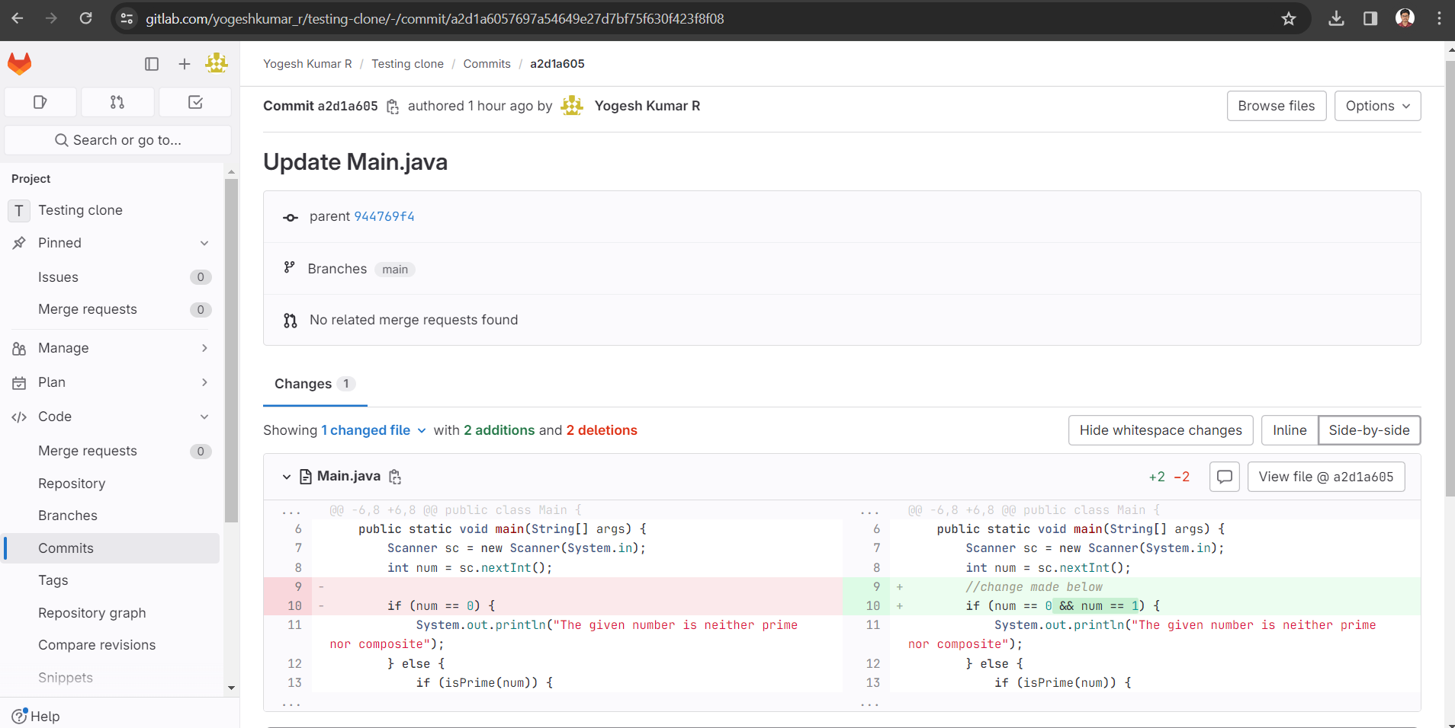

1. Requested to merge
2. Merge request Approved

